Press Release
Houston, TX, August 31, 2018- World Oil announced that The Drill2Frac Engineered Diversion Service is a finalist for a 2018 World Oil Award in the “Best Completions Category.” The winners will be revealed at a black-tie gala in Houston, TX, on Oct. 11. https://www.worldoil.com/events/wo-awards/2018-finalists
When hydraulically fracturing a horizontal wellbore with multiple perforation clusters, the fluid being pumped into the well will preferentially take the path of least resistance. Perforations that are located in the lowest stressed rocks will take a larger amount of fluid, and those perforations located in the highest stressed rocks will receive less fluid, or in some cases none.
One of the ways that engineers are trying to overcome these differences in rock properties, is the use of diverters. A stage with diverter is typically inserted at some point within a hydraulic fracturing pump schedule to seal off dominant fractures, allowing fluid to flow into under-stimulated fractures.
Engineered Diversion methodology currently in use by Drill2Frac examines well heterogeneity and designs the diversion strategy based on actual reservoir properties. This data is then used to bin clusters into primary clusters which will be treated first. This is followed by a diverter slug, then secondary and possibly tertiary clusters. The volume of diverter slug used will be proportional to the number of clusters within the previous bin.
Drill2Frac’s Engineered Diversion Strategy is the only commercial service that analyzes the effect of a well’s lateral heterogeneity on the completion design to help guide exactly where and when diversion occurs. As a result, clusters are stimulated in a controlled and predictable manner resulting in maximum productivity while minimizing screen outs.
About Drill2Frac
Drill2Frac LLC was founded in 2014 to create services for the factory drilling and completions segment of the oil industry. The solutions developed ultimately improve well productivity by using existing data and are provided with reduced HSE risk while maintaining a price point that fits within a tight, cost-controlled manufacturing environment.
The Drill2Frac service analytics are designed specifically to address multiple data issues. Rather than just providing a software program, we use a combination of deep domain expertise and several analytical tools to evaluate downhole and surface data. With this hybrid approach of subject matter experts and software analytical tools, Drill2Frac services uniquely turn raw disjointed data into actionable data.
####
For more information, contact:
Karl Sakocius
Director of Marketing
DrillFrac, LLC
281.467.0735
info@drill2frac.com

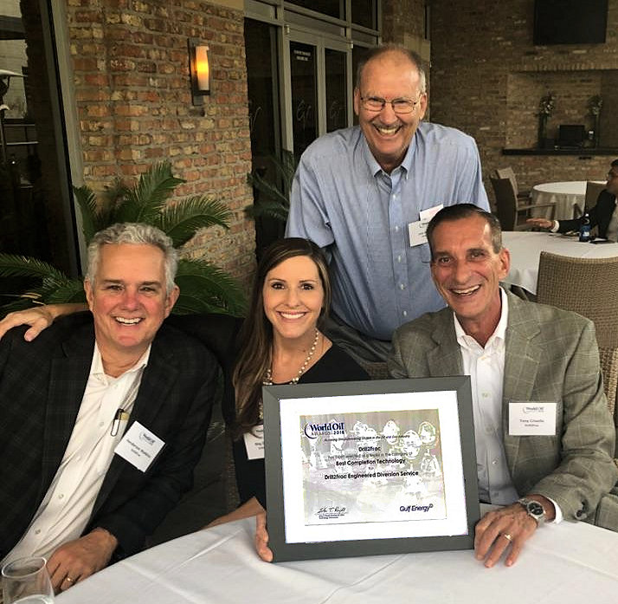
On hand to receive the nomination were (left to Right) Henderson Watkins, Meg Dodge, Lee Ramsey, and Tony Crivello.

